MATLAB Output:

Q48)

G =

100 s + 8250

------------------

s^2 + 100 s + 7625

Continuous-time transfer function.

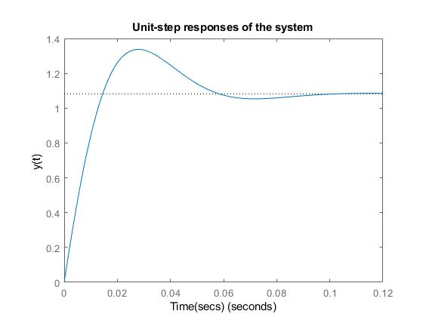

Q50)

G =

2000

------------------------

(s+10) (s^2 + 20s + 200)

Continuous-time zero/pole/gain model.

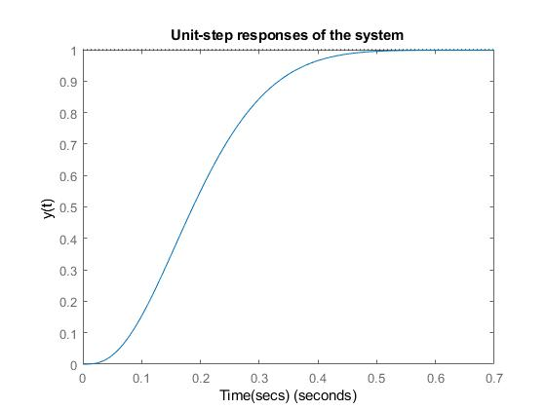

Q54)

Kv =

100\*Kp

1. 9/100
2. 657/5000
3. 19/100